UNIT II MOBILE NETWORK LAYER

Topics to be covered:
Mobile IP, Dynamic Host Configuration Protocol, Routing, DSDV, DSR, Alternative Metrics.

1. Mobile IP
The following gives an overall view of Mobile IP, and the extensions needed for the internet to support the mobility of hosts. This chapter introduces protocols and mechanisms developed for the network layer to support mobility. The Mobile IP adds mobility support to the internet network layer protocol IP.

1.1 Goals, assumptions and requirements
The internet is the network for global data communication with hundreds of millions of users. A host sends an IP packet with the header containing a destination address with other fields. The destination address not only determines the receiver of the packet, but also the physical subnet of the receiver. For example, the destination address 129.13.42.99 shows that the receiver must be connected to the physical subnet with the network prefix 129.13.42. Routers in the internet now look at the destination addresses of incoming packets and forward them according to internal look-up tables. To avoid an explosion of routing tables, only prefixes are stored and further optimizations are applied. A router would otherwise have to store the addresses of all computers in the internet, which is obviously not feasible. As long as the receiver can be reached within its physical subnet, it gets the packets; as soon as it moves outside the subnet, a packet will not reach it. A host needs a so-called topologically correct address.
A TCP connection is identified by the tuple (source IP address, source port, destination IP address, destination port), also known as a socket pair (a socket consists of address and port). Therefore, a TCP connection cannot survive any address change. Breaking TCP connections is not an option, using even simple programs like telnet would be impossible. The mobile node would also have to notify all communication partners about the new address. Another approach is the creation of specific routes to the mobile node. Routers always choose the best-fitting prefix for the routing decision. If a router now has an entry for a prefix 129.13.42 and an address 129.13.42.99, it would choose the port associated with the latter for forwarding, if a packet with the destination address 129.13.42.99 comes in. While it is theoretically possible to change routing tables all over the world to create specific routes to a mobile node, this does not scale at all with the number of nodes in the internet. Routers are built for extremely fast forwarding, but not for fast updates of routing tables. Routers are the ‘brains’ of the internet, holding the whole net together. No service provider or system administrator would allow changes to the routing tables, probably sacrificing stability, just to provide mobility for individual users.

1.2 Requirements
Several requirements accompanied the development of the standard:
- Compatibility
- Transparency
- Scalability and efficiency
- Security

1.3 Entities and terminology
The following defines several entities and terms needed to understand mobile IP as defined in RFC 3344.
- Mobile node (MN): A mobile node is an end-system or router that can change its point of attachment to the internet using mobile IP. The MN keeps its IP address and can continuously communicate with any other system in the internet as long as link-layer connectivity is given. Mobile nodes are not necessarily small devices such as laptops with antennas or mobile phones; a router onboard an aircraft can be a powerful mobile node.
- Correspondent node (CN): At least one partner is needed for communication. In the following the CN represents this partner for the MN. The CN can be a fixed or mobile node.
- Home network: The home network is the subnet the MN belongs to with respect to its IP address. No mobile IP support is needed within the home network.
- Foreign network: The foreign network is the current subnet the MN visits and which is not the home network.
- Foreign agent (FA): The FA can provide several services to the MN during its visit to the foreign network. The FA can have the COA, acting as tunnel endpoint and forwarding packets to the MN. The FA can be the default router for the MN. FAs can also provide security services because they belong to the foreign network as opposed to the MN which is only visiting. For mobile IP functioning, FAs are not necessarily needed. Typically, an FA is implemented on a router for the subnet the MN attaches to.
- Care-of address (COA): The COA defines the current location of the MN from an IP point of view. All IP packets sent to the MN are delivered to the COA, not directly to the IP address of the MN. Packet delivery toward the MN is done using a tunnel, as explained later. To be more precise, the COA marks the tunnel endpoint, i.e., the address where packets exit the tunnel.
There are two different possibilities for the location of the COA:
- Foreign agent COA: The COA could be located at the FA, i.e., the COA is an IP address of the FA. The FA is the tunnel end-point and forwards packets to the MN. Many MN using the FA can share this COA as common COA.
- Co-located COA: The COA is co-located if the MN temporarily acquired an additional IP address which acts as COA. This address is now topologically correct, and the tunnel endpoint is at the MN. Co-located addresses can be acquired using services such as DHCP. One problem associated with this approach is the need for additional addresses if MNs request a COA.
- Home agent (HA): The HA provides several services for the MN and is located in the home network. The tunnel for packets toward the MN starts at the HA. The HA maintains a location registry, i.e., it is informed of the MN’s location by the current COA. Three alternatives for the implementation of an HA exist. The HA can be implemented on a router that is responsible for the home network. This is obviously the best position, because without optimizations to mobile IP, all packets for the MN have to go through the router anyway.
If changing the router’s software is not possible, the HA could also be implemented on an arbitrary node in the subnet. One disadvantage of this solution is the double crossing of the router by the packet if the MN is in a foreign network. A packet for the MN comes in via the router; the HA sends it through the tunnel which again crosses the router. Finally, a home network is not necessary at all. The HA could be again on the ‘router’ but this time only acting as a manager for MNs belonging to a virtual home network. All MNs are always in a foreign network with this solution.
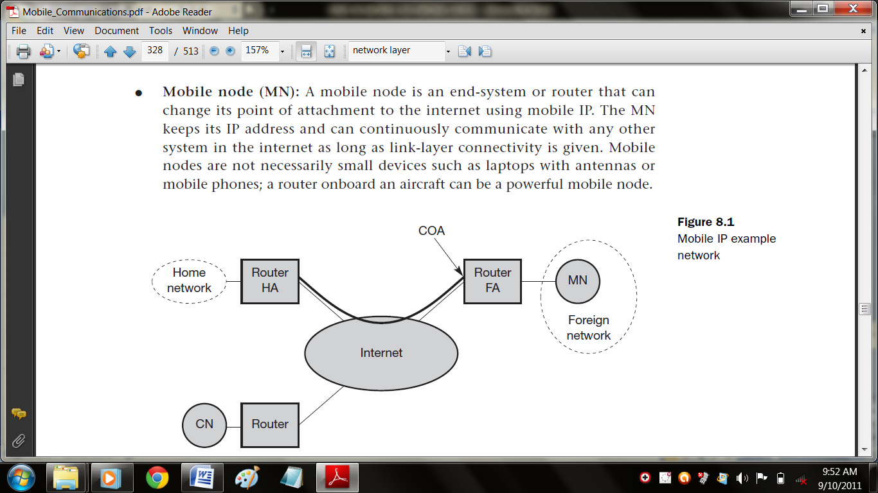
The example network in figure shows the following situation: A CN is connected via a router to the internet, as are the home network and the foreign network. The HA is implemented on the router connecting the home network with the internet, an FA is implemented on the router to the foreign network. The MN is currently in the foreign network. The tunnel for packets toward the MN starts at the HA and ends at the FA, for the FA has the COA in this example.

1.4 IP packet delivery
Figure illustrates packet delivery to and from the MN. A correspondent node CN wants to send an IP packet to the MN. One of the requirements of mobile IP was to support hiding the mobility of the MN.
- Step 1: CN does not need to know anything about the MN’s current location and sends the packet as usual to the IP address of MN. This means that CN sends an IP packet with MN as a destination address and CN as a source address. The internet, not having information on the current location of MN, routes the packet to the router responsible for the home network of MN. This is done using the standard routing mechanisms of the internet.
- Step 2: The HA now intercepts the packet, knowing that MN is currently not in its home network. The packet is not forwarded into the subnet as usual, but encapsulated and tunnelled to the COA. A new header is put in front of the old IP header showing the COA as new destination and HA as source of the encapsulated packet.
- Step 3: The foreign agent now decapsulates the packet, i.e., removes the additional header, and forwards the original packet with CN as source and MN as destination to the MN . Again, for the MN mobility is not visible. It receives the packet with the same sender and receiver address as it would have done in the home network.
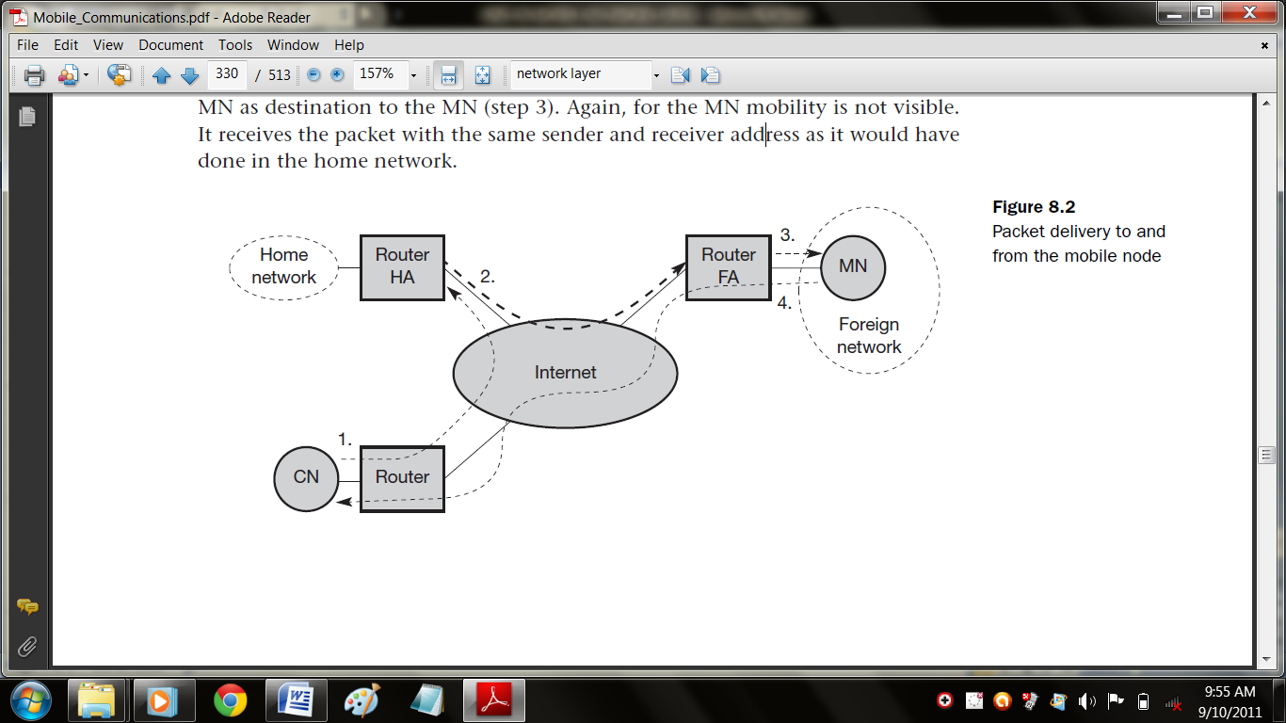
- Step 4: The MN sends the packet as usual with its own fixed IP address as source and CN’s address as destination. The router with the FA acts as default router and forwards the packet in the same way as it would do for any other node in the foreign network. As long as CN is a fixed node the remainder is in the fixed internet as usual. If CN were also a mobile node residing in a foreign network, the same mechanisms as described in steps 1 through 3 would apply now in the other direction.
The following sections present some additional mechanisms needed for mobile IP to work, some enhancements to the protocol, and some efficiency and security problems.

1.5 Agent discovery
One initial problem of an MN after moving is how to find a foreign agent. How does the MN discover that it has moved? For this purpose mobile IP describes two methods:
- Agent advertisement and
- Agent solicitation,
Which, are in fact router discovery methods plus extensions.

1.5.1 Agent advertisement
For the first method, foreign agents and home agents advertise their presence periodically using special agent advertisement messages. These advertisement messages can be seen as a beacon broadcast into the subnet. For these advertisements Internet control message protocol (ICMP) messages according to RFC 1256 are used with some mobility extensions. Routers in the
fixed network implementing this standard also advertise their routing service periodically to the attached links.
The agent advertisement packet according to RFC 1256 with the extension for mobility is shown in Figure. The upper part represents the ICMP packet while the lower part is the extension needed for mobility. The fields necessary on lower layers for the agent advertisement are not shown in this figure. Clearly, mobile nodes must be reached with the appropriate link layer address. The TTL field of the IP packet is set to 1 for all advertisements to avoid forwarding them. The IP destination address according to standard router advertisements can be either set to 224.0.0.1, which is the multicast address for all systems on a link, or to the broadcast address 255.255.255.255.
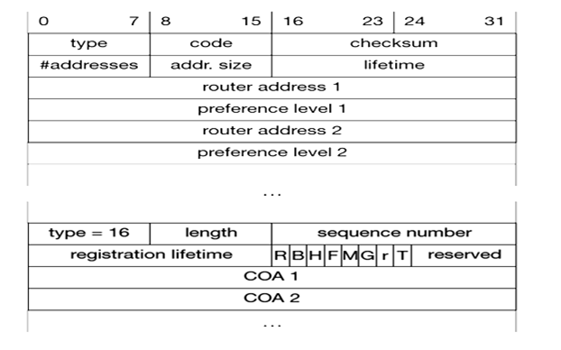
The fields in the ICMP part are defined as follows. The type is set to 9, the code can be 0, if the agent also routes traffic from non-mobile nodes, or 16, if it does not route anything other than mobile traffic. Foreign agents are at least required to forward packets from the mobile node. The number of addresses advertised with this packet is in #addresses while the addresses themselves follow as shown.
Lifetime denotes the length of time this advertisement is valid. Preference levels for each address help a node to choose the router that is the most eager one to get a new node. The difference compared with standard ICMP advertisements is what happens after the router addresses. This extension for mobility has the following fields defined: type is set to 16, length depends on the number of COAs provided with the message and equals 6 + 4*(number of addresses). An agent shows the total number of advertisements sent since initialization in the sequence number. By the registration lifetime the agent can specify the maximum lifetime
in seconds a node can request during registration.
The following bits specify the characteristics of an agent in detail.
- The R bit (registration) shows, if a registration with this agent is required even when using a colocated COA at the MN.
- If the agent is currently too busy to accept new registrations it can set the B bit.
- The following two bits denote if the agent offers services as a home agent (H) or foreign agent (F) on the link where the advertisement has been sent.
- Bits M and G specify the method of encapsulation used for the tunnel. While IP-in-IP encapsulation is the mandatory standard, M can specify minimal encapsulation and G generic routing encapsulation.
- In the first version of mobile IP (RFC 2002) the V bit specified the use of header compression according to RFC 1144.
- Now the field r at the same bit position is set to zero and must be ignored.
- The new field T indicates that reverse tunneling is supported by the FA.
- The following fields contain the COAs advertised. A foreign agent setting the F bit must advertise at least one COA.
A mobile node in a subnet can now receive agent advertisements from either its home agent or a foreign agent. This is one way for the MN to discover its location.

1.5.2 Agent solicitation
If no agent advertisements are present or the inter-arrival time is too high, and an MN has not received a COA by other means, the mobile node must send agent solicitations. These solicitations are again based on RFC 1256 for router solicitations. Care must be taken to ensure that these solicitation messages do not flood the network, but basically an MN can search for an FA endlessly sending out solicitation messages. Typically, a mobile node can send out three solicitations, One per second, as soon as it enters a new network. It should be noted that in highly dynamic wireless networks with moving MNs and probably with applications requiring continuous packet streams even one second intervals between solicitation messages might be too long. Before an MN even gets a new address many packets will be lost without additional mechanisms. If a node does not receive an answer to its solicitations it must decrease the rate of solicitations exponentially to avoid flooding the network until it reaches a maximum interval between solicitations (typically one minute). Discovering a new agent can be done anytime, not just if the MN is not connected to one. Consider the case that an MN is looking for a better connection while still sending via the old path. This is the case while moving through several cells of different wireless networks. After these steps of advertisements or solicitations the MN can now receive a COA, either one for an FA or a co-located COA. The MN knows its location (home network or foreign network) and the capabilities of the agent (if needed).
The next step for the MN is the registration with the HA if the MN is in a foreign network as described in the following.

1.6 Registration
Having received a COA, the MN has to register with the HA. The main purpose of the registration is to inform the HA of the current location for correct forwarding of packets. Registration can be done in two different ways depending on the location of the COA.
- If the COA is at the FA, registration is done as illustrated in following figure(left).
- The MN sends its registration request containing the COA to the FA which is forwarding the request to the HA. The HA now sets up a mobility binding containing the mobile node’s home IP address and the current COA. Additionally, the mobility binding contains the lifetime of the registration which is negotiated during the registration process. Registration expires automatically after the lifetime and is deleted; so, an MN should reregister before expiration. This mechanism is necessary to avoid mobility bindings which are no longer used. After setting up the mobility binding, the HA sends a reply message back to the FA which forwards it to the MN.
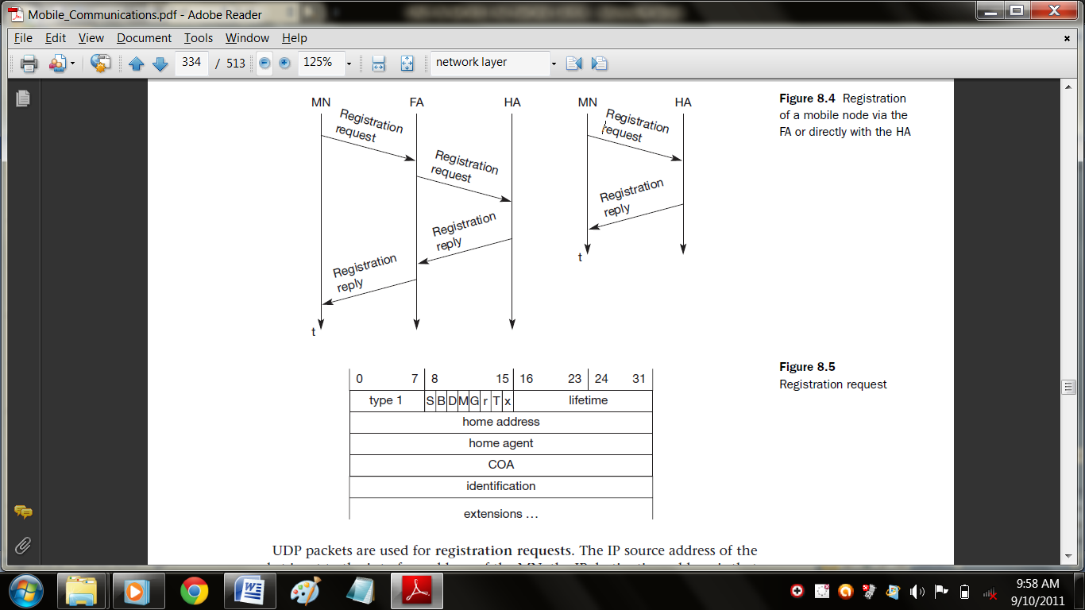
- If the COA is co-located, registration can be simpler, as shown in Figure (right). The MN may send the request directly to the HA and vice versa. This, by the way, is also the registration procedure for MNs returning to their home network. Here they also register directly with the HA. However, if the MN received an agent advertisement from the FA it should register via this FA if the R bit is set in the advertisement.
UDP packets are used for registration requests. The IP source address of the packet is set to the interface address of the MN, the IP destination address is that of the FA or HA (depending on the location of the COA). The UDP destination port is set to 434. UDP is used because of low overheads and better performance compared to TCP in wireless environments. The fields relevant for mobile IP registration requests follow as UDP data.
The fields are defined as follows. The first field type is set to 1 for a registration request. With the S bit an MN can specify if it wants the HA to retain prior mobility bindings. This allows for simultaneous bindings. The following bits denote the requested behavior for packet forwarding. Setting the B bit generally indicates that an MN also wants to receive the broadcast packets which have been received by the HA in the home network. If an MN uses a co-located COA, it also takes care of the decapsulation at the tunnel endpoint. The D bit indicates this behavior.
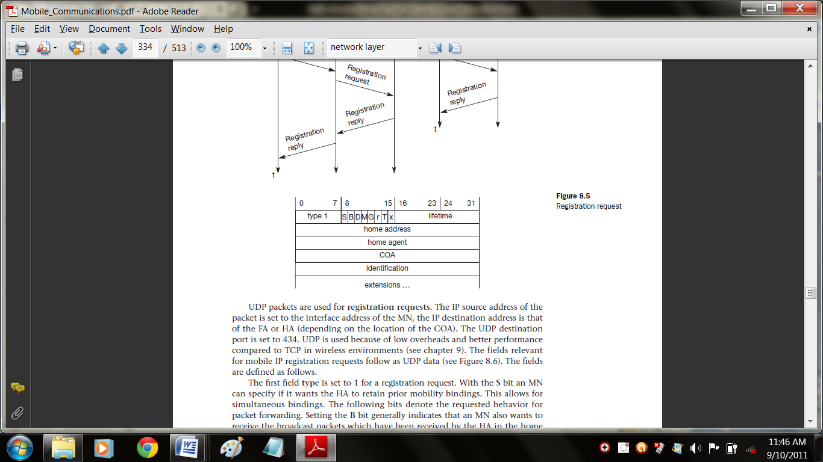
As already defined for agent advertisements, the following bits M and G denote the use of minimal encapsulation or generic routing encapsulation, respectively. T indicates reverse tunneling, r and x are set to zero. Lifetime denotes the validity of the registration in seconds. A value of zero indicates deregistration; all bits set indicates infinity. The home address is the fixed IP address of the MN, home agent is the IP address of the HA, and COA represents the tunnel endpoint. The 64 bit identification is generated by the MN to identify a request and match it with registration replies. This field is used for protection against replay attacks of registrations. The extensions must at least contain parameters for authentication.
A registration reply, which is conveyed in a UDP packet, contains a type field set to 3 and a code indicating the result of the registration request. Table gives some example codes.

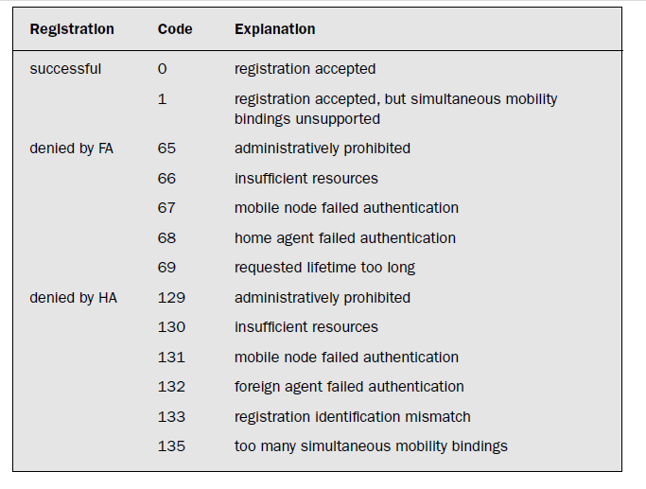
The lifetime field indicates how many seconds the registration is valid if it was successful. Home address and home agent are the addresses of the MN and the HA, respectively. The 64-bit identification is used to match registration requests with replies. The value is based on the identification field from the registration and the authentication method. Again, the extensions must at least contain parameters for authentication.
1.7 Tunneling and encapsulation
The following describes the mechanisms used for forwarding packets between the HA and the COA. A tunnel establishes a virtual pipe for data packets between a tunnel entry and a tunnel endpoint. Packets entering a tunnel are forwarded inside the tunnel and leave the tunnel unchanged. Tunneling, i.e., sending a packet through a tunnel, is achieved by using encapsulation.
Encapsulation is the mechanism of taking a packet consisting of packet header and data and putting it into the data part of a new packet. The reverse operation, taking a packet out of the data part of another packet, is called decapsulation. Encapsulation and decapsulation are the operations typically performed when a packet is transferred from a higher protocol layer to a lower layer or from a lower to a higher layer respectively. Here these functions are used within the same layer.
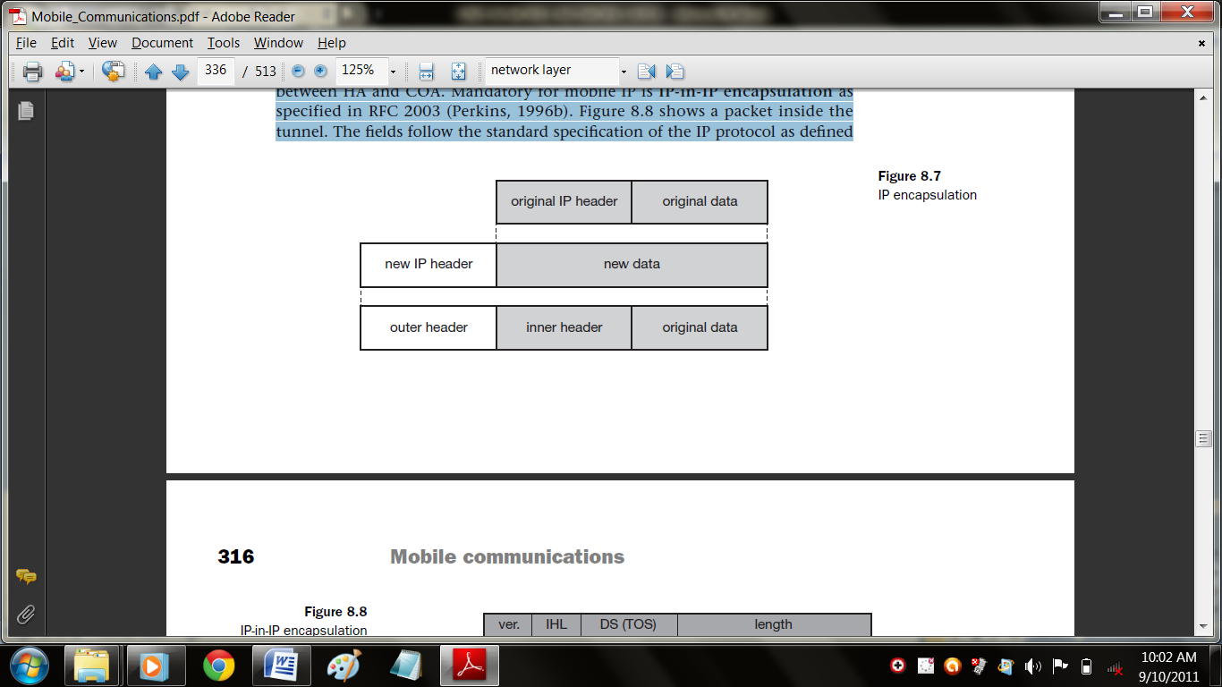
This mechanism is shown in Figure and describes exactly what the HA at the tunnel entry does. The HA takes the original packet with the MN as destination, puts it into the data part of a new packet and sets the new IP header in such a way that the packet is routed to the COA. The new header is also called the outer header for obvious reasons. Additionally, there is an inner header which can be identical to the original header as this is the case for IP-in-IP encapsulation, or the inner header can be computed during encapsulation.

1.7.1 IP-in-IP encapsulation
There are different ways of performing the encapsulation needed for the tunnel between HA and COA. Mandatory for mobile IP is IP-in-IP encapsulation as specified in RFC 2003. Following figure shows a packet inside the tunnel.
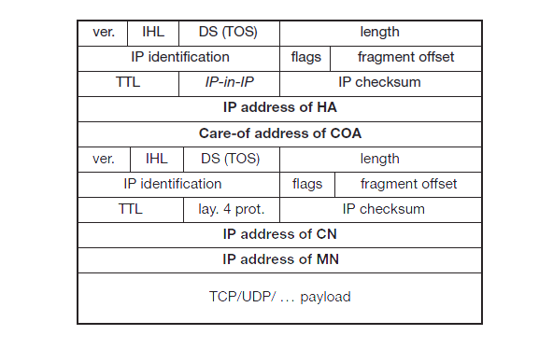
The fields follow the standard specification of the IP protocol as defined in RFC 791 and the new interpretation of the former TOS, now DS field in the context of differentiated services.
The fields of the outer header are set as follows. The version field ver is 4 for IP version
4, the internet header length (IHL) denotes the length of the outer header in 32 bit words. DS(TOS) is just copied from the inner header, the length field covers the complete encapsulated packet. The fields up to TTL have no special meaning for mobile IP and are set according to RFC 791. TTL must be high enough so the packet can reach the tunnel endpoint. The next field, here denoted with IP-in-IP, is the type of the protocol used in the IP payload. This field is set to 4, the protocol type for IPv4 because again an IPv4 packet follows after this outer header. IP checksum is calculated as usual. The next fields are the tunnel entry as source address (the IP address of the HA) and the tunnel exit point as destination address (the COA).
If no options follow the outer header, the inner header starts with the same fields as just explained. This header remains almost unchanged during encapsulation, thus showing the original sender CN and the receiver MN of the packet. The only change is TTL which is decremented by 1. This means that the whole tunnel is considered a single hop from the original packet’s point of view. This is a very important feature of tunneling as it allows the MN to behave as if it were attached to the home network. No matter how many real hops the packet has to take in the tunnel, it is just one (logical) hop away for the MN. Finally, the payload follows the two headers.

1.7.2 Minimal encapsulation
As seen with IP-in-IP encapsulation, several fields are redundant. For example, TOS is just copied, fragmentation is often not needed etc. Therefore, minimal encapsulation as shown in Figure is an optional encapsulation method for mobile IP.
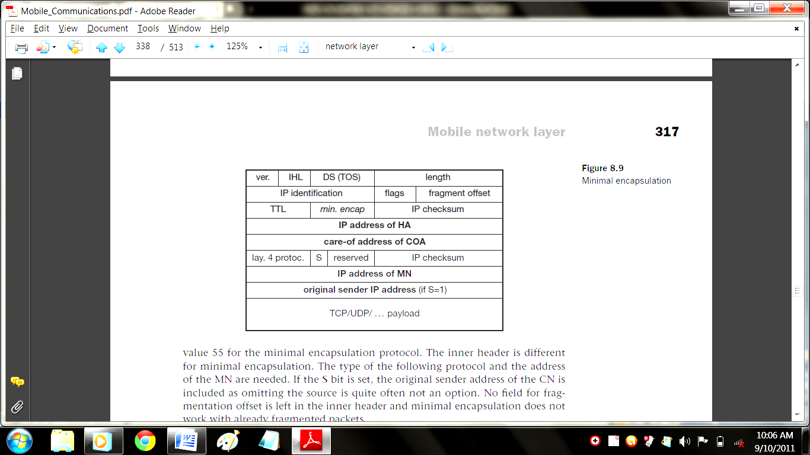
The tunnel entry point and endpoint are specified. In this case, the field for the type of the following header contains the value 55 for the minimal encapsulation protocol. The inner header is different for minimal encapsulation. The type of the following protocol and the address
of the MN are needed. If the S bit is set, the original sender address of the CN is included as omitting the source is quite often not an option. No field for fragmentation offset is left in the inner header and minimal encapsulation does not work with already fragmented packets.

1.7.3 Generic routing encapsulation
While IP-in-IP encapsulation and minimal encapsulation work only for IP, the following encapsulation scheme also supports other network layer protocols in addition to IP. Generic routing encapsulation (GRE) allows the encapsulation of packets of one protocol suite into the payload portion of a packet of another protocol suite. Figure shows this procedure.
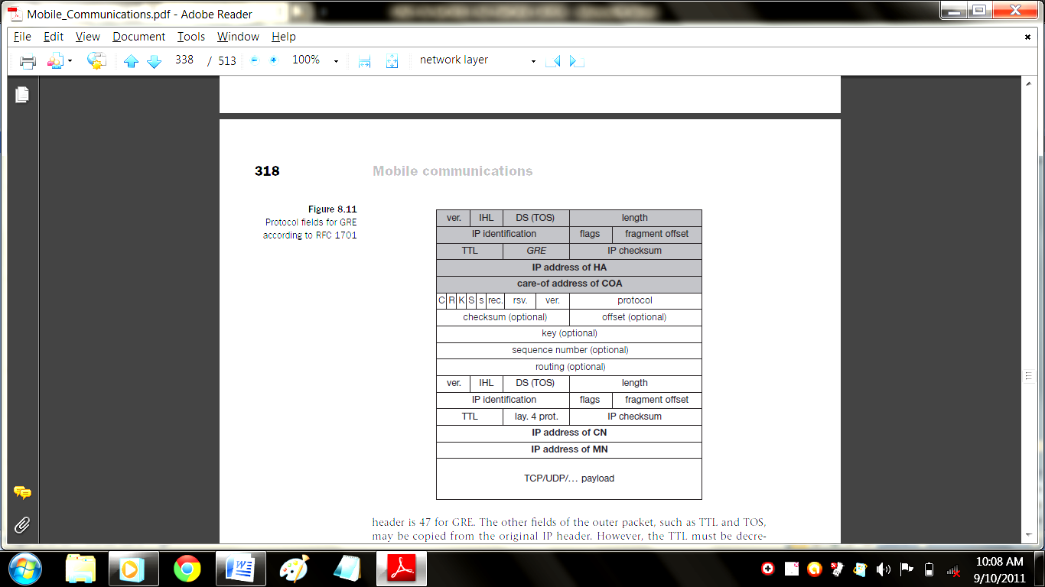

The packet of one protocol suite with the original packet header and data is taken and a new GRE header is prepended. Together this forms the new data part of the new packet. Finally, the header of the second protocol suite is put in front. Figure shows on the left side the fields of a packet inside the tunnel between home agent and COA using GRE as an encapsulation scheme according to RFC 1701. The outer header is the standard IP header with HA as source address and COA as destination address. The protocol type used in this outer IP header is 47 for GRE. The other fields of the outer packet, such as TTL and TOS, may be copied from the original IP header. However, the TTL must be decremented by 1 when the packet is decapsulated to prevent indefinite forwarding.
The GRE header starts with several flags indicating if certain fields are present or not. A minimal GRE header uses only 4 bytes; nevertheless, GRE is flexible enough to include several mechanisms in its header. The C bit indicates if the checksum field is present and contains valid information. If C is set, the checksum field contains a valid IP checksum of the GRE header and the payload. The R bit indicates if the offset and routing fields are present and contain valid information. The offset represents the offset in bytes for the first source routing entry. The routing field, if present, has a variable length and contains fields for source routing. If the C bit is set, the offset field is also present and, vice versa, if the R bit is set, the checksum field must be present. The only reason for this is to align the following fields to 4 bytes. The checksum field is
valid only if C is set, and the offset field is valid only if R is set respectively. GRE also offers a key field which may be used for authentication. If this field is present, the K bit is set. However, the authentication algorithms are not further specified by GRE. The sequence number bit S indicates if the sequence number field is present, if the s bit is set, strict source routing is used. Sequence numbers may be used by a decapsulator to restore packet order. This can be important, if a protocol guaranteeing in-order transmission is encapsulated and transferred using a protocol which does not guarantee in-order delivery, e.g., IP. Now the decapsulator at the tunnel exit must restore the sequence to maintain the characteristic of the protocol. The recursion control field (rec.) is an important field that additionally distinguishes GRE from IP-in-IP and minimal encapsulation.
This field represents a counter that shows the number of allowed recursive encapsulations. As soon as a packet arrives at an encapsulator it checks whether this field equals zero. If the field is not zero, additional encapsulation is allowed – the packet is encapsulated and the field decremented by one. Otherwise the packet will most likely be discarded. This mechanism prevents indefinite recursive encapsulation which might happen with the other schemes if tunnels are set up improperly (e.g., several tunnels forming a loop). The default value of this field should be 0, thus allowing only one level of encapsulation.
The following reserved fields must be zero and are ignored on reception. The version field contains 0 for the GRE version. The following 2 byte protocol field represents the protocol of the packet following the GRE header. Several values have been defined, e.g., 0 × 6558 for transparent Ethernet bridging using a GRE tunnel. In the case of a mobile IP tunnel, the protocol field contains 0 × 800 for IP. The standard header of the original packet follows with the source address of the correspondent node and the destination address of the mobile node.
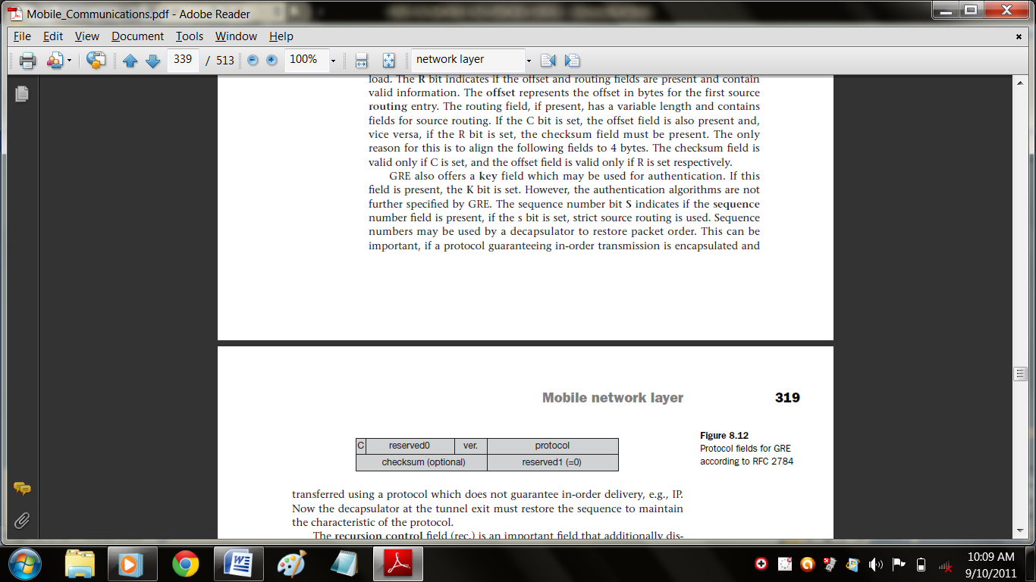
Above figure shows the simplified header of GRE following RFC 2784 , which is a more generalized version of GRE compared to RFC 1701. This version does not address mutual encapsulation and ignores several protocol-specific nuances on purpose. The field C indicates again if a checksum is present. The next 5 bits are set to zero, then 7 reserved bits follow. The version field contains the value zero. The protocol type, again, defines the protocol of the payload following RFC 3232. If the flag C is set, then checksum field and a field called reserved1 follows. The latter field is constant zero set to zero follow. RFC 2784 deprecates several fields of RFC 1701, but can interoperate with RFC 1701-compliant implementations.

1.8 Optimizations
Imagine the following scenario. A Japanese and a German meet at a conference on Hawaii. Both want to use their laptops for exchanging data, both run mobile IP for mobility support. If the Japanese sends a packet to the German, his computer sends the data to the HA of the German, i.e., from Hawaii to Germany. The HA in Germany now encapsulates the packets and tunnels them to the COA of the German laptop on Hawaii. This means that although the computers might be only meters away, packets have to travel around the world. This inefficient behavior of a non optimized mobile IP is called triangular routing. The triangle is made of the
three segments, CN to HA, HA to COA/MN, and MN back to CN.
With the basic mobile IP protocol all packets to the MN have to go through the HA. This can cause unnecessary overheads for the network between CN and HA, but also between HA and COA, depending on the current location of the MN. As the example shows, latency can increase dramatically. This is particularly unfortunate if the MNs and HAs are separated by, e.g., transatlantic links.
One way to optimize the route is to inform the CN of the current location of the MN. The CN can learn the location by caching it in a binding cache which is a part of the local routing table for the CN. The appropriate entity to inform the CN of the location is the HA. The optimized mobile IP protocol needs four additional messages.
- Binding request: Any node that wants to know the current location of an MN can send a binding request to the HA. The HA can check if the MN has allowed dissemination of its current location. If the HA is allowed to reveal the location it sends back a binding update.
- Binding update: This message sent by the HA to CNs reveals the current location of an MN. The message contains the fixed IP address of the MN and the COA. The binding update can request an acknowledgement.
- Binding acknowledgement: If requested, a node returns this acknowledgement after receiving a binding update message.
- Binding warning: If a node decapsulates a packet for an MN, but it is not the current FA for this MN, this node sends a binding warning. The warning contains MN’s home address and a target node address, i.e., the address of the node that has tried to send the packet to this MN. The recipient of the warning then knows that the target node could benefit from obtaining a fresh binding for the MN. The recipient can be the HA, so the HA should now send a binding update to the node that obviously has a wrong COA for the MN.

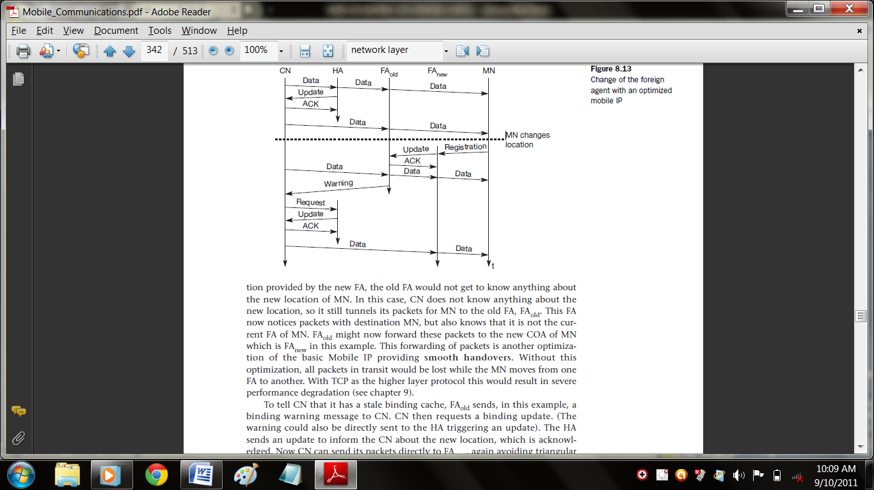
Figure explains these additional four messages together with the case of an MN changing its FA. The CN can request the current location from the HA. If allowed by the MN, the HA returns the COA of the MN via an update message. The CN acknowledges this update message and stores the mobility binding. Now the CN can send its data directly to the current foreign agent FA_{old}. FA_{old} forwards the packets to the MN. This scenario shows a COA located at an FA. Encapsulation of data for tunneling to the COA is now done by the CN, not the HA.
The MN might now change its location and register with a new foreign agent, FA_{new}. This registration is also forwarded to the HA to update its location database. Furthermore, FA_{new} informs FA_{old} about the new registration of MN. MN’s registration message contains the address of FA_{old} for this purpose. Passing this information is achieved via an update message, which is acknowledged by FA_{old}. Registration replies are not shown in this scenario. Without the information provided by the new FA, the old FA would not get to know anything about the new location of MN. In this case, CN does not know anything about the new location, so it still tunnels its packets for MN to the old FA, FA_{old}. This FA now notices packets with destination MN, but also knows that it is not the current FA of MN. FA_{old} might now forward these packets to the new COA of MN which is FAnew in this example. This forwarding of packets is another optimization of the basic Mobile IP providing smooth handovers. Without this optimization, all packets in transit would be lost while the MN moves from one FA to another. With TCP as the higher layer protocol this would result in severe performance degradation.
To tell CN that it has a stale binding cache, FA_{old} sends, in this example, a binding warning message to CN. CN then requests a binding update. (The warning could also be directly sent to the HA triggering an update). The HA sends an update to inform the CN about the new location, which is acknowledged. Now CN can send its packets directly to FA_{new}, again avoiding triangular routing. Unfortunately, this optimization of mobile IP to avoid triangular routing causes several security problems (e.g., tunnel hijacking). Not all users of mobile communication systems want to reveal their current ‘location’ (in the sense of an IP subnet) to a communication
partner.

1.8 Reverse tunneling
The MN can directly send its packets to the CN as in any other standard IP situation. The destination address in the packets is that of CN. But there are several severe problems associated with this simple solution.
- Firewalls: All data to and from the intranet must pass through the firewall. Besides many other functions, firewalls can be set up to filter out malicious addresses from an administrator’s point of view. Quite often firewalls only allow packets with topologically correct addresses to pass. This provides at least a first and simple protection against misconfigured systems of unknown addresses.
- Multi-cast: Reverse tunnels are needed for the MN to participate in a multicast group. While the nodes in the home network might participate in a multi-cast group, an MN in a foreign network cannot transmit multi-cast packets in a way that they emanate from its home network without a reverse tunnel.
Obviously, reverse tunneling now creates a triangular routing problem in the reverse direction. All packets from an MN to a CN go through the HA. Reverse tunneling also raises several security issues which have not been really solved up to now. For example, tunnels starting in the private network of a company and reaching out into the internet could be hijacked and abused for sending packets through a firewall. It is not clear if companies would allow for setting up tunnels through a firewall without further checking of packets. It is more likely that a company will set up a special virtual network for visiting mobile nodes outside the firewall with full connectivity to the internet. This allows guests to use their mobile equipment, and at the same time, today’s security standards are maintained.

2. Dynamic host configuration protocol (DHCP)
The dynamic host configuration protocol is mainly used to simplify the installation and maintenance of networked computers. If a new computer is connected to a network, DHCP can provide it with all the necessary information for full system integration into the network, e.g., addresses of a DNS server and the default router, the subnet mask, the domain name, and an IP address. Providing an IP address, makes DHCP very attractive for mobile IP as a source of care-of-addresses. While the basic DHCP mechanisms are quite simple, many options are available as described in RFC 2132.
DHCP is based on a client/server model as shown in Figure. DHCP clients send a request to a server (DHCPDISCOVER in the example) to which the server responds. A client sends requests using MAC broadcasts to reach all devices in the LAN. A DHCP relay might be needed to forward requests across inter-working units to a DHCP server.
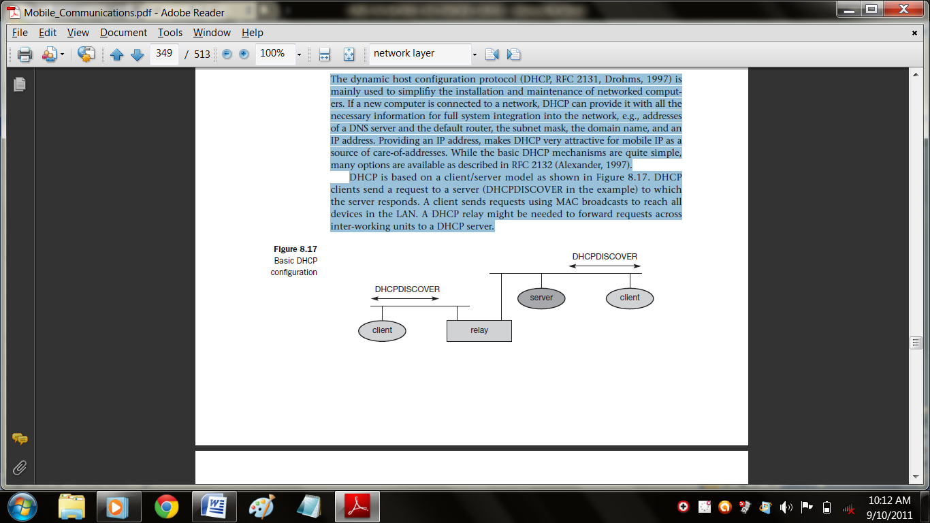
A typical initialization of a DHCP client is shown in Figure. The figure shows one client and two servers. As described above, the client broadcasts a DHCPDISCOVER into the subnet. There might be a relay to forward this broadcast. In the case shown, two servers receive this broadcast and determine the configuration they can offer to the client. One example for this could be the checking of available IP addresses and choosing one for the client. Servers reply to the client’s request with DHCPOFFER and offer a list of configuration parameters. The client can now choose one of the configurations offered. The client in turn replies to the servers, accepting one of the configurations and rejecting the others using DHCPREQUEST. If a server receives a DHCPREQUEST with a rejection, it can free the reserved configuration for other possible clients.
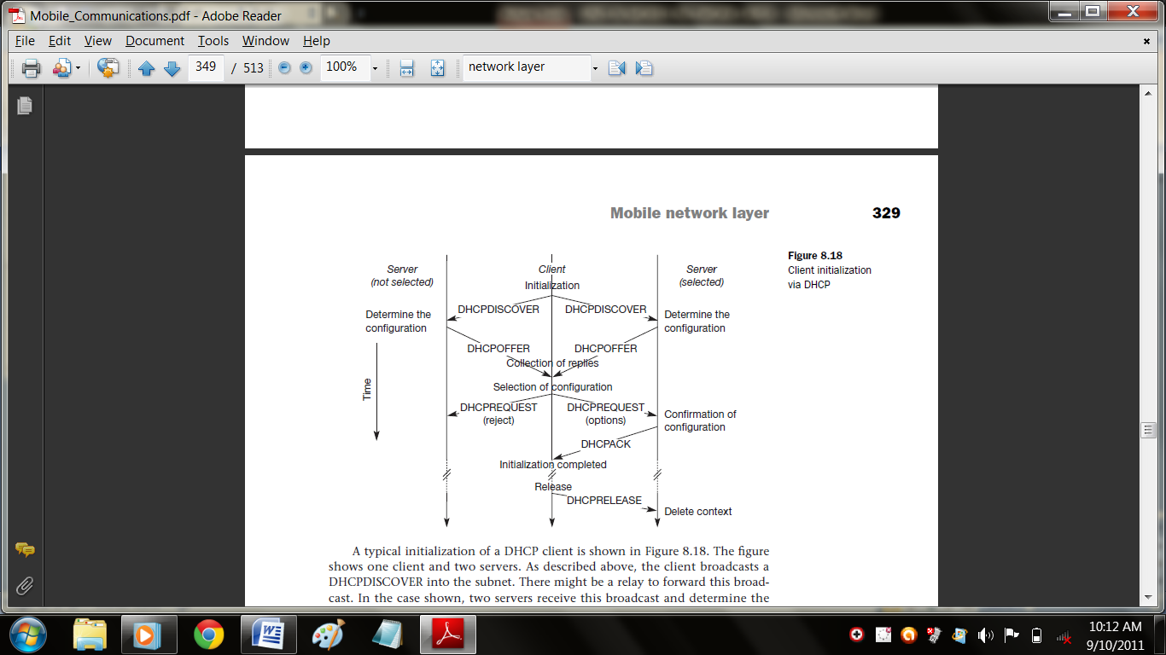

The server with the configuration accepted by the client now confirms the configuration
with DHCPACK. This completes the initialization phase. If a client leaves a subnet, it should release the configuration received by the server using DHCPRELEASE. Now the server can free the context stored for the client and offer the configuration again. The configuration a client gets from a server is only leased for a certain amount of time, it has to be reconfirmed from time to time. Otherwise the server will free the configuration. This timeout of configuration helps in the case of crashed nodes or nodes moved away without releasing the context.
DHCP is a good candidate for supporting the acquisition of care-of addresses for mobile nodes. The same holds for all other parameters needed, such as addresses of the default router, DNS servers, the timeserver etc. A DHCP server should be located in the subnet of the access point of the mobile node, or at least a DHCP relay should provide forwarding of the messages. RFC 3118 specifies authentication for DHCP messages which is needed to protect mobile nodes from malicious DHCP servers. Without authentication, the mobile node cannot trust a DHCP server, and the DHCP server cannot trust the mobile node.

3. Mobile ad-hoc networks(MANET)
Mobile IP requires, e.g., a home agent, tunnels, and default routers. DHCP requires servers and broadcast capabilities of the medium reaching all participants or relays to servers. Cellular phone networks require base stations, infrastructure networks etc. However, there may be several situations where users of a network cannot rely on an infrastructure, it is too expensive, or there is none at all. In these situations mobile ad-hoc networks are the only choice. It is important to note that this section focuses on so-called multi-hop ad-hoc networks when describing adhoc networking. The ad-hoc setting up of a connection with an infrastructure is not the main issue here. These networks should be mobile and use wireless communications. Examples for the use of such mobile, wireless, multi-hop ad-hoc networks, which are only called ad-hoc networks here for simplicity, are:
- Instant infrastructure: Unplanned meetings, spontaneous interpersonal communications etc. cannot rely on any infrastructure. Infrastructures need planning and administration. It would take too long to set up this kind of infrastructure; therefore, ad-hoc connectivity has to be set up.
- Disaster relief: Infrastructures typically break down in disaster areas. Hurricanes cut phone and power lines, floods destroy base stations, fires burn servers. Emergency teams can only rely on an infrastructure they can set up themselves. No forward planning can be done, and the set-up must be extremely fast and reliable. The same applies to many military activities, which is, to be honest, one of the major driving forces behind mobile ad-hoc networking research.
- Remote areas: Even if infrastructures could be planned ahead, it is sometimes too expensive to set up an infrastructure in sparsely populated areas. Depending on the communication pattern, ad-hoc networks or satellite infrastructures can be a solution.
- Effectiveness: Services provided by existing infrastructures might be too expensive for certain applications. If, for example, only connection oriented cellular networks exist, but an application sends only a small status information every other minute, a cheaper ad-hoc packet-oriented network might be a better solution. Registration procedures might take too long, and communication overheads might be too high with existing networks. Application-tailored ad-hoc networks can offer a better solution.
Over the last few years ad-hoc networking has attracted a lot of research interest. This has led to creation of a working group at the IETF that is focusing on mobile ad-hoc networking, called MANET . Figure shows the relation of MANET to mobile IP and DHCP.
While mobile IP and DHCP handle the connection of mobile devices to a fixed infrastructure, MANET comprises mobile routers, too. Mobile devices can be connected either directly with an infrastructure using Mobile IP for mobility support and DHCP as a source of many parameters, such as an IP address. MANET research is responsible for developing protocols and components to enable ad-hoc networking between mobile devices. It should be noted that the separation of end system and router is only a logical separation. Typically, mobile nodes in an adhoc scenario comprise routing and end system functionality.
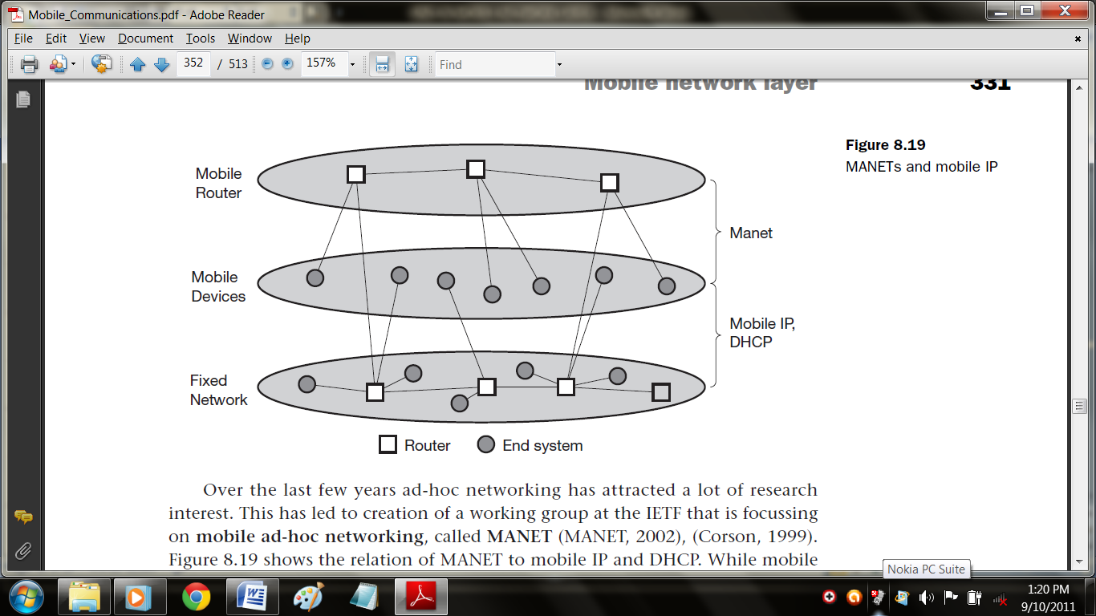
One of the first ad-hoc wireless networks was the packet radio network started by ARPA in 1973. It allowed up to 138 nodes in the ad-hoc network and used IP packets for data transport. This made an easy connection possible to the ARPA net, the starting point of today’s Internet. Twenty radio channels between 1718.4–1840 MHz were used offering 100 or 400 kbit/s. The system used DSSS with 128 or 32 chips/bit.
A variant of distance vector routing was used in this ad-hoc network. In this approach, each node sends a routing advertisement every 7.5 s. These advertisements contain a neighbor table with a list of link qualities to each neighbor. Each node updates the local routing table according to the distance vector algorithm based on these advertisements. Received packets also help to update the routing table. A sender now transmits a packet to its first hop neighbor using the local neighbor table. Each node forwards a packet received based on its own local neighbor table. Several enhancements to this simple scheme are needed to avoid routing loops and to reflect the possibly fast changing topology. The following sections discuss routing problems and enhanced routing mechanisms for ad-hoc networks in more detail.

4. Adhoc Network Routing Technique
While in wireless networks with infrastructure support a base station always reaches all mobile nodes, this is not always the case in an ad-hoc network. A destination node might be out of range of a source node transmitting packets. Routing is needed to find a path between source and destination and to forward the packets appropriately. In wireless networks using an infrastructure, cells have been defined. Within a cell, the base station can reach all mobile nodes
without routing via a broadcast. In the case of ad-hoc networks, each node must be able to forward data for other nodes. This creates many additional problems that are discussed in the following paragraphs.
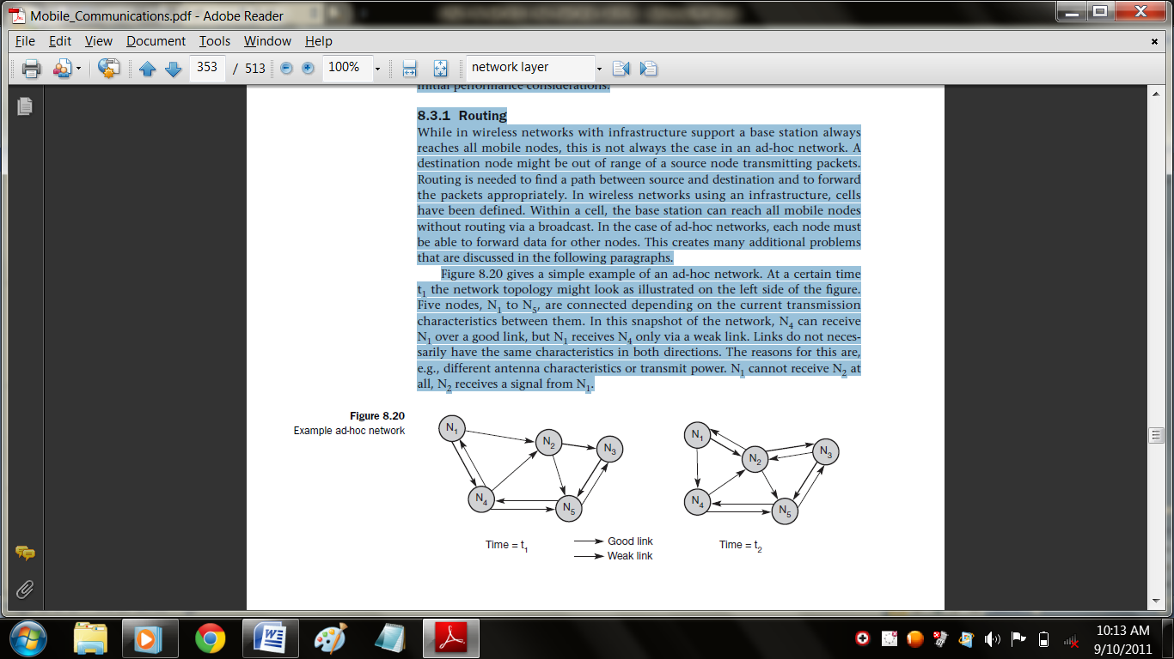
Figure gives a simple example of an ad-hoc network. At a certain time t1 the network topology might look as illustrated on the left side of the figure.
Five nodes, N1 to N5, are connected depending on the current transmission characteristics between them. In this snapshot of the network, N4 can receive N1 over a good link, but N1 receives N4 only via a weak link. Links do not necessarily have the same characteristics in both directions. The reasons for this are, e.g., different antenna characteristics or transmit power. N1 cannot receive N2 at all, N2 receives a signal from N1. This situation can change quite fast as the snapshot at t2 shows. N1 cannot receive N4 any longer, N4 receives N1 only via a weak link. But now N1 has an asymmetric but bi-directional link to N2 that did not exist before. This very simple example already shows some fundamental differences between wired networks and ad-hoc wireless networks related to routing.
- Asymmetric links: Node A receives a signal from node B. But this does not tell us anything about the quality of the connection in reverse. B might receive nothing, have a weak link, or even have a better link than the reverse direction. Routing information collected for one direction is of almost no use for the other direction. However, many routing algorithms for wired networks rely on a symmetric scenario.
- Redundant links: Wired networks, too, have redundant links to survive link failures. However, there is only some redundancy in wired networks, which, additionally, are controlled by a network administrator. In ad-hoc networks nobody controls redundancy, so there might be many redundant links up to the extreme of a completely meshed topology. Routing algorithms for wired networks can handle some redundancy, but a high redundancy can cause a large computational overhead for routing table updates.
- Interference: In wired networks links exist only where a wire exists, and connections are planned by network administrators. This is not the case for wireless ad-hoc networks. Links come and go depending on transmission characteristics, one transmission might interfere with another, and nodes might overhear the transmissions of other nodes. Interference creates new problems by ‘unplanned’ links between nodes: if two close-by nodes forward two transmissions, they might interfere and destroy each other. On the other hand, interference might also help routing. A node can learn the topology with the help of packets it has overheard.
- Dynamic topology: The greatest problem for routing arises from the highly dynamic topology. The mobile nodes might move as shown in Figure or medium characteristics might change. This results in frequent changes in topology, so snapshots are valid only for a very short period of time. In adhoc networks, routing tables must somehow reflect these frequent changes in topology, and routing algorithms have to be adapted. Routing algorithms used in wired networks would either react much too slowly or generate too many updates to reflect all changes in topology. Routing table updates in fixed networks, for example, take place every 30 seconds. This updating frequency might be too low to be useful for ad-hoc networks. Some algorithms rely on a complete picture of the whole network. While this works in wired networks where changes are rare, it fails completely in ad-hoc networks. The topology changes during the distribution of the ‘current’ snapshot of the network, rendering the snapshot useless.
Let us go back to the example network in Figure and assume that node N1 wants to send data to N3 and needs an acknowledgement. If N1 had a complete overview of the network at time t1, which is not always the case in ad-hoc networks, it would choose the path N1, N2, N3, for this requires only two hops (if we use hops as metric). Acknowledgements cannot take the same path, N3 chooses N3, N5, N4, N1. This takes three hops and already shows that routing also strongly influences the function of higher layers. TCP, for example, makes round trip measurements assuming the same path in both directions. This is obviously wrong in the example shown, leading to misinterpretations of measurements and inefficiencies. Just a moment later, at time t2, the topology has changed. Now N3 cannot take the same path to send acknowledgements back to N1, while N1 can still take the old path to N3. Although already more complicated than fixed networks, this example still assumes that nodes can have a complete insight into the current situation. The optimal knowledge for every node would be a description of the current connectivity between all nodes, the expected traffic flows, capacities of all links, delay of each link, and the computing and battery power of each node. While even in fixed networks traffic flows are not exactly predictable, for ad-hoc networks link capacities are additionally unknown.
The capacity of each link can change from 0 to the maximum of the transmission technology used. In real ad-hoc networks no node knows all these factors, and establishing up-to-date snapshots of the network is almost impossible. Ad-hoc networks using mobile nodes face additional problems due to hardware limitations. Using the standard routing protocols with periodic updates wastes battery power without sending any user data and disables sleep modes. Periodic updates waste bandwidth and these resources are already scarce for wireless links. An additional problem is interference between two or more transmissions that do not use the same nodes for forwarding. If, for example, a second transmission from node N4 to N5 takes place at the same time as the transmission from N1 to N3, they could interfere. Interference could take place at N2 which can receive signals from N1 and N4, or at N5 receiving N4 and N2. If shielded correctly, there is no interference between two wires.
Considering all the additional difficulties in comparison to wired networks, the following observations concerning routing can be made for ad-hoc networks with moving nodes.
- Traditional routing algorithms known from wired networks will not work efficiently (e.g., distance vector algorithms such as RIP converge much too slowly) or fail completely (e.g., link state algorithms such as OSPF exchange complete pictures of the network). These algorithms have not been designed with a highly dynamic topology, asymmetric links, or interference in mind.
- Routing in wireless ad-hoc networks cannot rely on layer three knowledge alone. Information from lower layers concerning connectivity or interference can help routing algorithms to find a good path.
- Centralized approaches will not really work, because it takes too long to collect the current status and disseminate it again. Within this time the topology has already changed.
- Many nodes need routing capabilities. While there might be some without, at least one router has to be within the range of each node. Algorithms have to consider the limited battery power of these nodes.
- The notion of a connection with certain characteristics cannot work properly. Ad-hoc networks will be connectionless, because it is not possible to maintain a connection in a fast changing environment and to forward data following this connection. Nodes have to make local decisions for forwarding and send packets roughly toward the final destination.
- A last alternative to forward a packet across an unknown topology is flooding. This approach always works if the load is low, but it is very inefficient. A hop counter is needed in each packet to avoid looping, and the diameter of the ad-hoc network, i.e., the maximum number of hops, should be known. (The number of nodes can be used as an upper bound.) Hierarchical clustering of nodes might help. If it is possible to identify certain groups of nodes belonging together, clusters can be established. While individual nodes might move faster, the whole cluster can be rather stationary. Routing between clusters might be simpler and less dynamic.
5. Destination sequence distance vector
Destination sequence distance vector (DSDV) routing is an enhancement to distance vector routing for ad-hoc networks. DSDV can be considered historically, however, an on-demand version is among the protocols currently discussed. Distance vector routing is used as routing information protocol (RIP) in wired networks. It performs extremely poorly with certain network changes due to the count-to-infinity problem. Each node exchanges its neighbor table periodically with its neighbors. Changes at one node in the network propagate slowly through the network (step-by-step with every exchange). The strategies to avoid this problem which are used in fixed networks do not help in the case of wireless ad-hoc networks, due to the rapidly changing topology. This might create loops or unreachable regions within the network.
DSDV now adds two things to the distance vector algorithm:
- Sequence numbers: Each routing advertisement comes with a sequence number. Within ad-hoc networks, advertisements may propagate along many paths. Sequence numbers help to apply the advertisements in correct order. This avoids the loops that are likely with the unchanged distance vector algorithm.
- Damping: Transient changes in topology that are of short duration should not destabilize the routing mechanisms. Advertisements containing changes in the topology currently stored are therefore not disseminated further. A node waits with dissemination if these changes are probably unstable. Waiting time depends on the time between the first and the best announcement of a path to a certain destination.
For each node N1 stores the next hop toward this node, the metric (here number of hops), the sequence number of the last advertisement for this node, and the time at which the path has been installed first. The table contains flags and a settling time helping to decide when the path can be assumed stable. Router advertisements from N1 now contain data from the first, third, and
fourth column: destination address, metric, and sequence number. Besides being loop-free at all times, DSDV has low memory requirements and a quick convergence via triggered updates.

6. Dynamic source routing
Imagine what happens in an ad-hoc network where nodes exchange packets from time to time, i.e., the network is only lightly loaded, and DSDV or one of the traditional distance vector or link state algorithms is used for updating routing tables. Although only some user data has to be transmitted, the nodes exchange routing information to keep track of the topology. These algorithms maintain routes between all nodes, although there may currently be no data exchange at all. This causes unnecessary traffic and prevents nodes from saving battery power.
Dynamic source routing (DSR), therefore, divides the task of routing into two separate problems:
- Route discovery: A node only tries to discover a route to a destination if it has to send something to this destination and there is currently no known route.
- Route maintenance: If a node is continuously sending packets via a route, it has to make sure that the route is held upright. As soon as a node detects problems with the current route, it has to find an alternative.
The basic principle of source routing is also used in fixed networks, e.g. token rings. Dynamic source routing eliminates all periodic routing updates and works as follows. If a node needs to discover a route, it broadcasts a route request with a unique identifier and the destination address as parameters. Any node that receives a route request does the following.
- If the node has already received the request (which is identified using the unique identifier), it drops the request packet.
- If the node recognizes its own address as the destination, the request has reached its target.
- Otherwise, the node appends its own address to a list of traversed hops in the packet and broadcasts this updated route request.
Using this approach, the route request collects a list of addresses representing a possible path on its way towards the destination. As soon as the request reaches the destination, it can return the request packet containing the list to the receiver using this list in reverse order. One condition for this is that the links work bi-directionally. If this is not the case, and the destination node does not currently maintain a route back to the initiator of the request, it has to start a route discovery by itself. The destination may receive several lists containing different paths from the initiator. It could return the best path, the first path, or several paths to offer the initiator a choice.
- The basic algorithm for route discovery can be optimized in many ways.
- To avoid too many broadcasts, each route request could contain a counter. Every node rebroadcasting the request increments the counter by one. Knowing the maximum network diameter (take the number of nodes if nothing else is known), nodes can drop a request if the counter reaches this number.
- A node can cache path fragments from recent requests. These fragments can now be used to answer other route requests much faster (if they still reflect the topology!).
- A node can also update this cache from packet headers while forwarding other packets.
- If a node overhears transmissions from other nodes, it can also use this information for shortening routes.
After a route has been discovered, it has to be maintained for as long as the node sends packets along this route. Depending on layer two mechanisms, different approaches can be taken:
- If the link layer uses an acknowledgement the node can interpret this acknowledgement as an intact route.
- If possible, the node could also listen to the next node forwarding the packet, so getting a passive acknowledgement.
A node could request an explicit acknowledgement. Again, this situation is complicated if links are not bi-directional. If a node detects connectivity problems, it has to inform the sender of a packet, initiating a new route discovery starting from the sender. Alternatively, the node could try to discover a new route by itself.
Although dynamic source routing offers benefits compared to other algorithms by being much more bandwidth efficient, problems arise if the topology is highly dynamic and links are asymmetrical.

7.Alternative metrics
The examples shown in this chapter typically use the number of hops as routing metric. Although very simple, especially in wireless ad-hoc networks, this is not always the best choice. Even for fixed networks, e.g., bandwidth can also be a factor for the routing metric. Due to the varying link quality and the fact that different transmissions can interfere, other metrics can be more useful. One other metric, called least interference routing (LIR), takes possible interference into account. Figure shows an ad-hoc network topology. Sender S1 wants to send a packet to receiver R1, S2 to R2. Using the hop count as metric, S1 could choose three different paths with three hops, which is also the minimum. Possible paths are (S1, N3, N4, R1), (S1, N3, N2, R1), and (S1, N1, N2, R1). S2 would choose the only available path with only three hops (S2, N5, N6, R2). Taking interference into account, this picture changes.

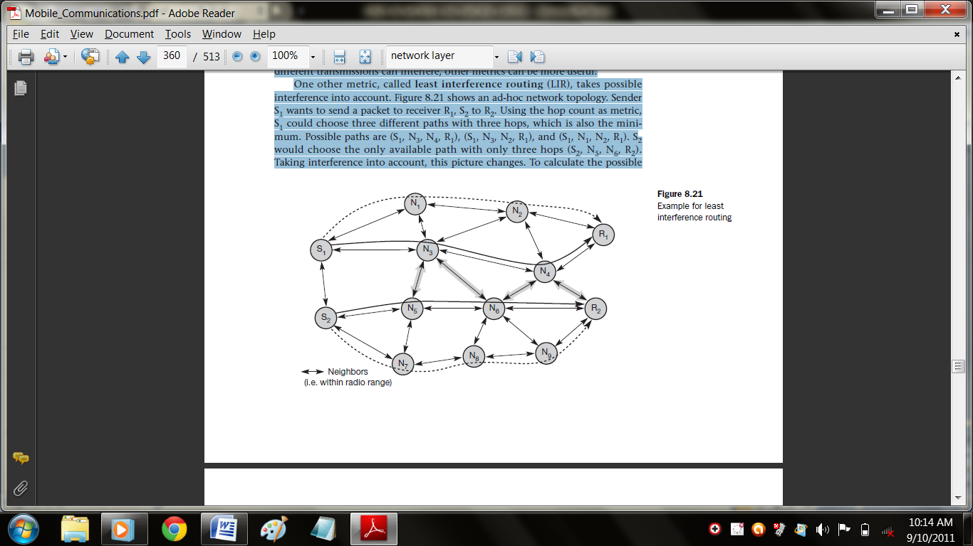

To calculate the possible interference of a path, each node calculates its possible interference (interference is defined here as the number of neighbors that can overhear a transmission). Every node only needs local information to compute its interference. In this example, the interference of node N3 is 6, that of node N4 is 5 etc. Calculating the costs of possible paths between S1 and R1 results in the following:
- C1 = cost(S1, N3, N4, R1) = 16,
- C2 = cost(S1, N3, N2, R1) = 15,
- C3 = cost(S1, N1, N2, R1) = 12.
All three paths have the same number of hops, but the last path has the lowest cost due to interference. Thus, S1 chooses (S1, N1, N2, R1). S2 also computes the cost of different paths, examples are C4 = cost(S2, N5, N6, R2) = 16 and C5 = cost(S2, N7, N8, N9, R2) = 15. S2 would, therefore, choose the path (S2, N7, N8, N9, R2), although this path has one hop more than the first one.
With both transmissions taking place simultaneously, there would have been interference between them as shown in Figure 8.21. In this case, least interference routing helped to avoid interference. Taking only local decisions and not knowing what paths other transmissions take, this scheme can just lower the probability of interference. Interference can only be avoided if all
senders know of all other transmissions (and the whole routing topology) and base routing on this knowledge.
Routing can take several metrics into account at the same time and weigh them. Metrics could be the number of hops h, interference i, reliability r, error rate e etc. The cost of a path could then be determined as:
cost = αh + βi + γr + δe + ...

It is not at all easy (if even possible) to choose the weights α, β, γ, δ,... to achieve the desired routing behavior.

Part-A

- Draw the Basic DHCP configuration.
- Define care of address.
- What is encapsulation and decapsulation?
- Compare foreign agent COA and co-located COA.
- How the tunneling process is achieved?
- List out the additional messages needed for optimized mobile IP protocol?
- Define route discovery and route maintenance.
- Draw the framework of IP-in-IP encapsulation.
- Give a diagrammatic example for Mobile IP Network.
- What is Damping?
Part-B
1. i) Explain in detail about the several entities and terminologies involved in Mobile IP. (10)
ii) Write a short note on IP Packets delivery.(6)
2. Describe about the IP-in-IP and generic routing encapsulation. (16)
3. Describe the following,
i) Adhoc network routing technique.(12)
ii) Destination sequences distance vector.(4)
4. Explain about the DHCP and MANET. (16)
5. Discuss in detail about the following,
i) Optimization in Mobile IP.(6)
ii)Registration of the mobile node.(10)
6. i)Explain about Agent discovery in Mobile IP. (12)
ii)Write a note on minimal encapsulation. (4)

